Temasek Polytechnic
School of Informatics and IT

Diploma in Information Technology (IT)

CGE2C09 Software Engineering

Tutor: Goh Mya Hu, Mel
Class: P01
Matric Number | Student Name
1506070J | Lexus George (Leader)
1503103B | Ryan Ng Zi Feng
1501169E | Yip Cherng Yorng
1502712A | Leng Yin Long

Lexus George
What is Software Development Life Cycle (SDLC)?
It is a process where used in the industry to design, develop and test high quality software’s within the organization, which aims to produce high quality software to meet customer’s expectations, finishing within times and cost estimates. It also defines a methodology for improving the quality of software and overall development process. A common SDLC consists of the following stages: Planning, Defining, Designing, Building, Testing and Deployment.

Planning
- This process is where important people like senior members gather inputs from customers to experts in the industry. It is use to conduct research based from the information gathered. It will also identify risk throughout the process.

Defining
- Once planning is done, this process is where it defines what the product requirements needs and get approval from the customer. It uses SRS (Software Requirement Software) document where all requirements needed to be developed during the life cycle.

Designing
- This process takes the reference from SRS, where it designs the proposed software accordingly to the requirements. It uses a DDS (Design Document Software) documentation, where it involves all important people like stakeholders and review the design of the product, from budget, time and risk.

Building
- This process where developers starts coding, using programming tools like java, C, C++. The programming tools depends on what type of software is needed based on the previous process in designing.

Testing
- This process is where after the product prototype is done, it tests for bugs, errors and others so that it can be rectified by the developers and reaching its required standards.

Deployment
- Once the testing is done, the product is readily to the market to use. The product release may contain certain bugs and issue after the handover of the product. And so gathering feedback from customer and maintenance of product.

There are three models that I am going to explain, which are Waterfall Model, Iterative Model and Spiral Model.

Waterfall model
It was the first used in the industry, also known as linear-sequential life cycle model. It was simple and easy to use as each process must be completed before moving to the next phase can start and no overlapping process. Also, the outcome of each phases acts as an input for the next phase.

It is applicable to use where requirements are clear, fixed and well acknowledged, product explanation is firm, technology is understood and not dynamic, no high requirements, sufficient resources with mandatory expertise are obtainable to assist the product and short project timeline.

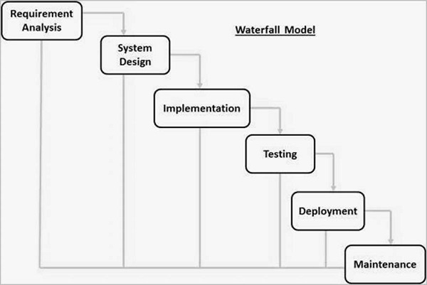
Figure 1: Waterfall model

As seen in figure 1 above, it represents the different phases of the Waterfall model. Requirement analysis is where it gathers all information needed first and written in a specific document. Next System design takes information from the first phase, identifying the right hardware and system needed. Implementation takes from the system design phase, where it develops into small programs named units, which will be use on the next phase. Each unit tested for functionality and developed is known as unit testing. After implementation, it goes into functional and non-functional testing where it tests the system for any errors and failures. Once testing is done, it is then ready for release to customers to use and market. Lastly, maintenance is needed as there is bugs which is needed to be fixed, enhance the product and changes to the customer environment.

The advantages of waterfall development are it is easy to manage due to the firmness of the model as each phase has specific deliverables and a review process, simple and easy to use, phases are processed and completed one at a time, works well on small projects where requirements are clear, easy to organize task, process and results are well written.
However, there are some disadvantages of waterfall development is that it does not allow reflection and changes to it. Once the application is in testing stage, it is hard to revert to make changes that is not well written. There are other factors which are no working software is out until later stage, higher risk, not wise to use on complex projects, poor for long and continuous projects, not suitable which projects is prone to higher risk of changing from time to time, hard to measure progress during stages and cannot have room for changing requirements.

Iterative Model
It is where the process starts from a set of simple software requirements, repeatedly improving current version till the system is ready to deploy and used. It does not begin with full requirements like how waterfall model, rather it starts from a specific and implementing part of the software needed, which also further analyse for more requirements.

It is applicable for uses in industries where all set of completed system requirements are well-defined though some improvements may change over time, opportunity to the market, new technology being used and learnt concurrently with project, required skillsets based on exact iteration and few tough features and goals that may change.

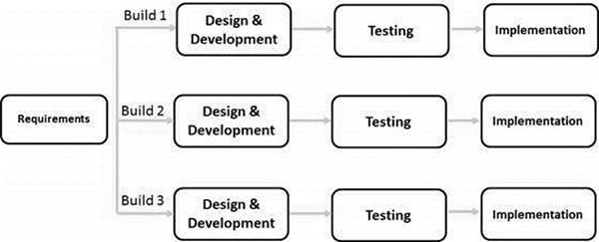
Figure 2: Iterative and Incremental Model

During each iteration, design changes and functions are added. The rule behind this method to come out with the system through repetitive cycles and in small chunks within a time. As seen in figure 2, it is show how the model works on both iterative and incremental method for development and design. For each iteration, it goes through the requirements, design, implementation and testing stages. It adds more functions to each stage from last version and continues until it completes the system accordingly. The main success of using this iterative software development is it goes through strict confirmation of needs, and checking and testing each version of the software as compared to waterfall model since it has continuous verifications and testing.

The advantage of this model are some working functions can be done fast and early in the life cycle, earlier regularly results, measurable growth of software, less expenditure to change requirements, less risk involved, noticeable risk is detected earlier, less operating time in the beginning, suited to big and important projects and early software release to help customer assessment.

However, there are some disadvantages of using the Iterative model where it may need more required resources, not advisable for tweaking requirements, more administration thinking and complications, system design may crop up due to insufficient information collected from initial, not applicable to small projects, unable to identify risk at the end of the project as higher cost is needed and highly reliant on progression.

Agile Model
This model is a fusion of iterative and incremental process which focus on adaptability and customer satisfaction. It breaks into small builds which provides iterations, lastly from one to three weeks. Each of the iteration consist of planning, requirement analysis, design, coding, unit testing and acceptance testing. After each testing, it is shown to the customer and stakeholders.

Agile uses adaptive software development methods compared to other models that I shared above. Other models use predictive methods, which depends on requirement analysis and planning, which has step-by-step protocols and priority. Agile uses the approach where there is no need for detailed planning, which is more future features that needs to be added and developed in the system. The product is handled by a team when there is requirement changes, goes through a lot of testing and reducing risk in the future.
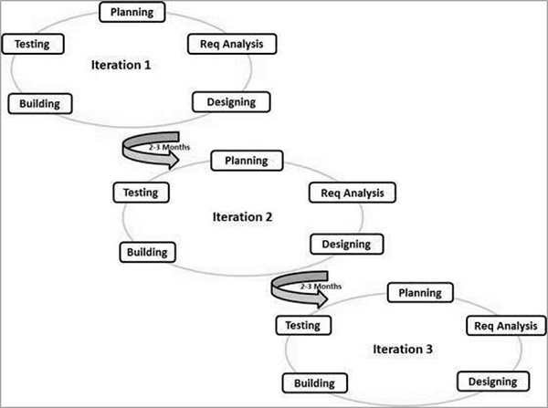

The advantages of this model are it is practical in software development, encourages teamwork and training, software functions can be progressed quickly and established, not much requirements needed, applicable to software that is fixed or shifting requirements, easily maintained and many others
However, there are some disadvantages of the model is that it is not workable on projects that has a lot of difficult needs, high risk on sustainability, maintainability and adaptability, both leader and project manager must work together, having strict management, rely highly on customer interaction, high reliance due to produced minimal documentation and new team members might find it hard to learn due to technology.

Ryan
What is Software Development Life Cycle (SDLC)?
Software Development Life Cycle (SDLC) is a process adopted for a software project. It consists of detailed plan describing how to develop, maintain, replace and alter or enhance a specific software. This life cycle defines a methodology for improving the quality of software and its overall development process. A common SDLC consist of the following stages: Planning, Defining, Designing, Building, Testing and Deployment. Also, there are various SDLC models defined and designed and each model follow a series of steps unique to its type to ensure the success in the process of software development. Some models are Agile Model, Waterfall Model and Iterative Model.

Agile Model:
This model is a combination of iterative and incremental process models with focus on process adaptability and customer satisfaction by quick delivery of working software product. It also breaks the product into small incremental builds and are provided in iterations which lasts from about one to three weeks. Every iteration consists of: Planning, Requirement Analysis, Design, Coding, Unit Testing and Acceptance Testing.

Waterfall Model:
This model was the first to be introduced and is very simple to use and understand. Each phase in the model must be completed before the next one can begin and there is no overlapping in the phases. However, using this model may result in high amount of risk and uncertainty.

Iterative Model:
This model starts with a simple implementation of a small set of software requirements and iteratively improve the versions until the complete system is implemented and ready to deploy. This model does not start with a full specification. Instead, development begins by specifying and implementing part of the software which is then reviewed to improve and identify further requirements. Hence producing new versions at the end of each iteration of the model.

Yip Cherng Yorng
What is Software Development Life Cycle (SDLC)?
SDLC show us about the life cycle of the whole development of a software from the start to the deployment of the software. In the cycle, there are 5 phrase of how the software is being made. The 5 phrase are requirement engineering, analysis and design, implementation, testing and deployment. This will give a clear view of how the project is being develop and as a guideline of developing the software.

Before a team start to develop the software, they must first decide on which development models they’re going to use.

Waterfall Model
The first development modal is Waterfall. This method is use when the team know the requirement and when the requirement is static. As what the name suggest, waterfall goes down. So, the procedure of the project is that it will start from requirement engineering and goes on until deployment and it cannot go up. So once when the development goes to another stage, you cannot change and mistakes or modify anything from the previous stage.

Prototyping Model
Then next development modal is prototyping. As what the name says, the team will do a prototype first before making the real system. This method is use to show the prototype to clarify with the sponsor and stakeholder to let them approve the idea first. This model has 2 process, throw-away and evolutionary. Throw away are prototype with features that sponsor doesn’t understand or not up to the requirement, so they are discarded. For those prototypes that are good and approve, the team will use it for evolutionary where they will continue to refine the prototype to be even better.

Agile Model
Finally, the third development modal is agile model. This model is usually use for making an app as the team would normally consist about 7+-2 people. Plus, they also must rush to finish parts of their features. The teamwork and the project leader must know what the team are doing since they only have a short amount of time to finish each features of the system.

Leng Yin Long
What is Software Development Life Cycle (SDLC)?
System Development Life Cycle (SDLC) is the system’s life cycle concept that defines the work phrases that are operated by system developers and system engineers who plans, test, makes, builds and delivers IT systems. The purpose of having SDLC is to construct high quality systems that meet the user’s needs or even exceed their expectations. All these are done through cost estimates and very tight time frames.

Phases in SDLC
- Requirements engineering
Finds out what the user (either client or customer) wants the software to do

- Analysis & Design
Analysis: Uses a combination of text and diagrammatic forms to find out requirements

Design: Produce a representation of an entity that will later be built on. Include architectural design, user interface design, database design, etc.

- Implementation (Coding)
Detailed designs converted into instructions written in the programming language(s)

- Testing
Ensures that software integrity is good, reliable, meets the users’ needs and does not run into errors during operations.

- Deployment
Application distributed among a group of selected customers prior to official release; project is brought to life and people starts using them to meet the needs of the company.
Application delivered to customer (may involve training)

Cite 3 software development models and its working concept
Waterfall Process
- What is waterfall model?
  - Waterfall method divides the software development into separate phases and every phase is an input for the following phase.

- Pros
  - Divide complex task into smaller and hence more manageable tasks (maintain control).
  - Each task gives a well-defined deliverable (documentation driven).
  - Easy to control and monitor as you deal with one activity at a time.
  - Works more effectively as requirements are well understood.

- Cons
  - Can only see the product at the end; no opportunity to validate user requirements at initial stages of development:
“I know this is what I asked for, but it isn’t really what I want.”
  - If a problem is discovered at an earlier stage, nothing can be done about it 1(traditional waterfall).
  - Does not stress the need for anticipating changes.
  - Not ideal for projects with requirements changes very frequently.
  - It is not possible to produce working software until the project reaches the testing and deployment stages of the cycle.
  - This model can only be used when very precise up-front requirements are given.

- When is it useful for use?
  - It is used for the project which is small and there are no uncertain requirements.

Prototyping Model
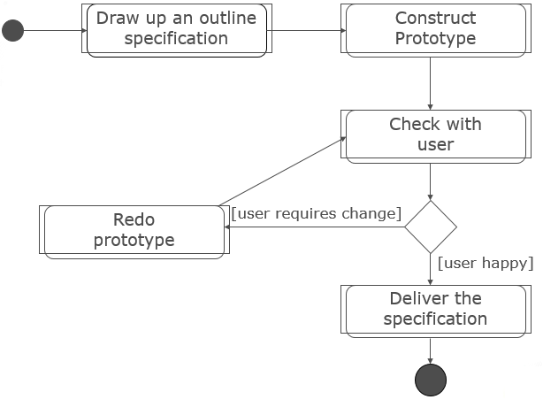
- What is prototyping model?
  - Prototyping model is prototyping a system or product repeatedly until it is acceptable to the user (either customer or client). The best feature of this software development methodologies is that it solves many problems which often arises from the traditional waterfall model.

- Pros
  - Clarifies user requirements with user (either customer or client).
  - Specifications can be developed incrementally, giving users opportunity to change their mind.
  - Reduces the risk of failure as risk can be identified during the initial stages.
  - Communication between software development team and user will be conductive as there will be a lot of prototyping involved and presentation to the user.
  - Assist in gathering requirements and requirement analysis especially when there are insufficient requirement documents.

- Cons
  - Estimating, planning and managing a prototype project can be difficult because there are no regular deliverables e.g. how to predict how many iterations?
  - Continual changes tend to corrupt software structure. Changes become more costly and difficult.
  - Too many modifications may not good for the project, as it easily interrupts the workflow of the entire software development team

- When is it useful for use?
  - Prototype model should be used when the desired system needs to have a lot of interaction with the end users. Typically, online systems, web interfaces have a very high amount of interaction with end users, are best suited for Prototype model. It might take a while for a system to be built that allows ease of use and needs minimal training for the end user. Prototyping ensures that the end users constantly work with the system and provide a feedback which is incorporated in the prototype to result in a useable system. They are excellent for designing good human computer interface systems.

Unified Process (UP)
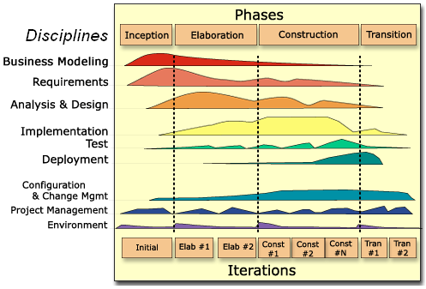
- What is unified process?
  - Unified process is a software development process framework for deriving a specific process model for the project on hand. This framework divides the project into 4 phases of RUP, namely inception, elaboration (milestone), construction (release) and transition (final production release).

- Pros
  - Unified process is risk-focused as it requires the team to focus on solving the most critical risks as soon as possible in the project life cycle.
  - High focus on accurate documentation.
  - Very little requirement for integration.
  - Proactively resolving project risks.

- Cons
  - Require expert software developer.
  - Development procedure is very complicated.
  - Integration may cause confusion within the company, especially during the testing stages.
  - Confusing and not easy to understand.

- When is it useful for use?
  - It is useful for object-based and web-empowered program growth methodology.

Application of any theoretical mentions to project
We will be adopting the waterfall model as it is a simple and easy to understand method which will benefit beginner and novice developers such as myself. Because it is easy to manage and easy to understand, with each phase having specific deliverables and individual review processes, the project can be completed and processed once at a time, hence saving a very significant amount of time.

